# 1
import tensorflow as tf
from tensorflow import keras
import matplotlib.pyplot as plt
(X_train,y_train), (X_test,y_test) = keras.datasets.mnist.load_data()
X_train = X_train / 255.0
X_test = X_test / 255.0
X_train = X_train.reshape(-1, 28*28)
X_test = X_test.reshape(-1, 28*28)
model = keras.Sequential([
keras.layers.Dense(128, activation ='relu', input_shape=(784,)),
keras.layers.Dense(64, activation='relu'),
keras.layers.Dense(10, activation='softmax')
])
model.compile(
optimizer='adam',
loss='sparse_categorical_crossentropy',
metrics=['accuracy'])
model.fit(X_train, y_train, epochs=5)
test_loss, test_acc = model.evaluate(X_test, y_test)
print("Test Accuracy:", test_acc)
predictions = model.predict(X_test[:5])
for i in range(5):
print("Predicted class:", predictions[i].argmax()) # <- fixed index bug
plt.imshow(X_test[i].reshape(28,28), cmap='gray')
plt.show()

#2) SINGLE PERCEPTRON USING LINEARLY SEPERABLE DATASET
import numpy as np
from sklearn.linear_model import Perceptron
import matplotlib.pyplot as plt
np.random.seed(42)
class_0= np.random.randn(50,2)+[6,6]
class_1= np.random.randn(50,2)+[2,2]
X=np.vstack((class_0,class_1))
y=np.hstack((np.zeros(50), np.ones(50)))
model = Perceptron(max_iter=1000, tol=1e-3)
model.fit(X,y)
print("Weights:",model.coef_)
print("Bias:", model.intercept_)
plt.scatter(X[:50,0], X[:50,1], color='red', label='Class 0')
plt.scatter(X[50:,0], X[50:,1], color='blue', label='Class 1')
x_vals=np.linspace(X[:,0].min(),X[:,0].max(),100)
y_vals=-(model.coef_[0][0]*x_vals+model.intercept_)/model.coef_[0][1]
plt.plot(x_vals,y_vals,color='green', label='Decision Boundary')
plt.legend()
plt.xlabel("Feature 1")
plt.ylabel("Feature 2")
plt.title("Perceptron Classification")
plt.show()

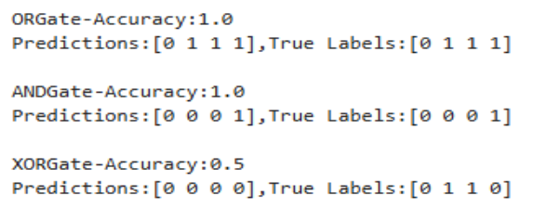

#3.Backpropagation using Artificial Neural Network
import numpy as np
sig = lambda x: 1/(1+np.exp(-x))
dsig = lambda x: x*(1-x)
X = np.array([[0,0], [0,1], [1,0], [1,1]])
y = np.array([[0],[1],[1],[0]])
np.random.seed(1)
W1 = np.random.randn(2,4)
W2 = np.random.randn(4,1)
lr = 0.1
for i in range(5000):
h = sig(X @ W1)
o = sig(h @ W2)
d2 = (y - o) * dsig(o)
d1 = d2 @ W2.T * dsig(h)
W2 += h.T @ d2 * lr
W1 += X.T @ d1 * lr

if i % 1000 == 0:
print(f'Epoch {i}, Loss: {np.mean((y-o)**2):.6f}')
print("\nFinal Predictions:")
print(o.round(3))

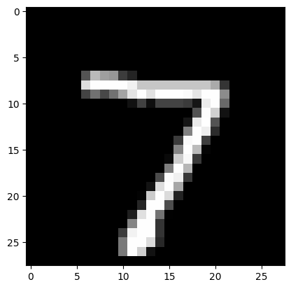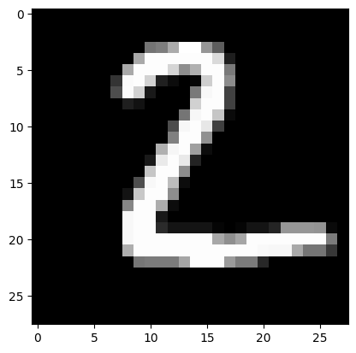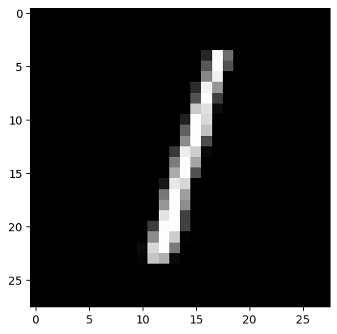
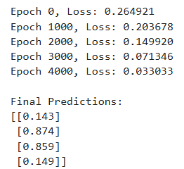 3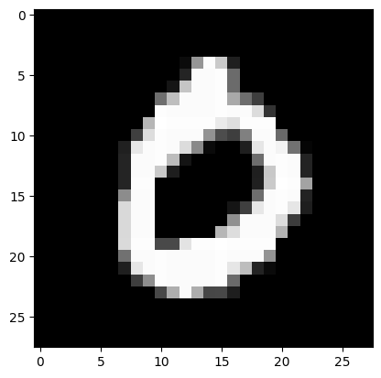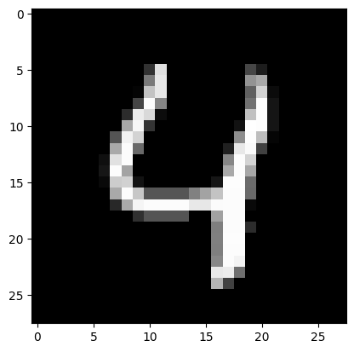

# 4
import numpy as np
from tensorflow.keras.datasets import mnist
from tensorflow.keras.models import Sequential
from tensorflow.keras.layers import Dense, Flatten
from tensorflow.keras.utils import to_categorical
(x_train, y_train), (x_test, y_test) = mnist.load_data()
x_train = x_train / 255.0
x_test = x_test / 255.0
y_train = to_categorical(y_train)
y_test = to_categorical(y_test)
model = Sequential([
Flatten(input_shape=(28, 28)),
Dense(128, activation='relu'),
Dense(64, activation='relu'),
Dense(10, activation='softmax')
])
model.compile(
optimizer='adam',
loss='categorical_crossentropy',
metrics=['accuracy']
)
model.fit(x_train, y_train, epochs=3, verbose=1)
loss, acc = model.evaluate(x_test, y_test, verbose=0)
pred = model.predict(x_test[:5]).argmax(axis=1)
print("\nOUTPUT")
print("Test Accuracy:", acc)
print("Predicted Classes:", pred)
print("Actual Classes:", np.argmax(y_test[:5], axis=1))

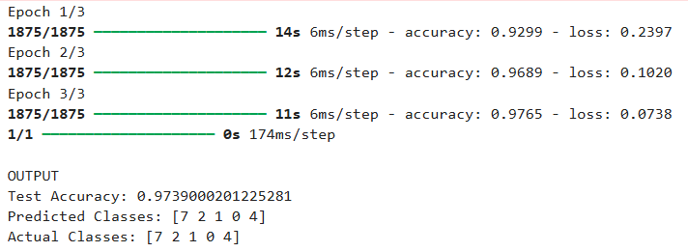 4
# 5.Implementation of Convolutional Neural Network (CNN)
import numpy as np
from tensorflow.keras.datasets import mnist
from tensorflow.keras.models import Sequential
from tensorflow.keras.layers import Conv2D, MaxPooling2D, Flatten, Dense
(x_train, y_train), (x_test, y_test) = mnist.load_data()
x_train = x_train.reshape(-1, 28, 28, 1) / 255.0
x_test = x_test.reshape(-1, 28, 28, 1) / 255.0
model = Sequential([
Conv2D(32, (3, 3), activation='relu', input_shape=(28, 28, 1)),
MaxPooling2D((2, 2)),
Conv2D(64, (3, 3), activation='relu'),
MaxPooling2D((2, 2)),
Flatten(),
Dense(64, activation='relu'),
Dense(10, activation='softmax')
])
model.compile(optimizer='adam', loss='sparse_categorical_crossentropy', metrics=['accuracy'])
model.fit(x_train, y_train, epochs=2, verbose=0)
loss, acc = model.evaluate(x_test, y_test, verbose=0)
pred = model.predict(x_test[:5]).argmax(axis=1)
print("\n=")
print("Test Accuracy:", acc)
print("OUTPUT=")
print("Predicted Digits:", pred)
print("Actual Digits:", y_test[:5])

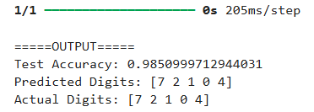 5
# 6. RNN to Generate a Sequence and Predict Next Number
import numpy as np
from tensorflow.keras.models import Sequential
from tensorflow.keras.layers import SimpleRNN, Dense
X = np.array([[1,2,3,4,5]])
y = np.array([6])
X = X.reshape((1,5,1))
model = Sequential()
model.add(SimpleRNN(10, activation='relu', input_shape= (5,1)))
model.add(Dense(1))
model.compile(optimizer='adam', loss='mse')
model.fit(X, y, epochs=300, verbose=0)
print("Predicted next number:", model.predict(X))

# 7. Transfer Learning using Inbuilt Dataset
from tensorflow.keras.applications import MobileNetV2
from tensorflow.keras.models import Sequential
from tensorflow.keras.layers import Dense, Flatten
from tensorflow.keras.datasets import cifar10
(x_train, y_train), (x_test, y_test) = cifar10.load_data()
base_model = MobileNetV2(weights='imagenet',include_top=False, input_shape=(32,32,3))
base_model.trainable = False
model = Sequential([base_model,Flatten(),Dense(10, activation='softmax')])
model.compile(optimizer='adam',loss='sparse_categorical_crossentropy', metrics=['accuracy'])
model.fit(x_train, y_train, epochs=1)

# 8. Autoencoder for Image Reconstruction
from tensorflow.keras.datasets import mnist
from tensorflow.keras.models import Sequential
from tensorflow.keras.layers import Dense, Flatten, Reshape
(x_train, _), (x_test, _) = mnist.load_data()
x_train = x_train/255.0
x_test = x_test/255.0
model = Sequential([Flatten(input_shape=(28, 28)),Dense(64, activation='relu'),Dense(784, activation='sigmoid'),Reshape((28, 28)) ])
model.compile(optimizer='adam', loss='binary_crossentropy')
model.fit(x_train, x_train, epochs=3)

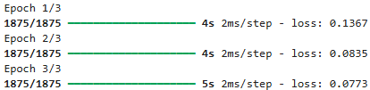 8

# 9. Data Augmentation using Inbuilt Dataset
from tensorflow.keras.preprocessing.image import ImageDataGenerator
from tensorflow.keras.datasets import mnist
import numpy as np
(x_train, _), (x_test, _) = mnist.load_data()
x_train = x_train.reshape(-1, 28, 28, 1)
datagen = ImageDataGenerator(rotation_range=20, zoom_range=0.2)
for batch in datagen.flow(x_train[:1], batch_size=1):
print("Augmented image generated")
break

10
from tensorflow.keras.datasets import mnist
from tensorflow.keras.models import Sequential
from tensorflow.keras.layers import Conv2D, AveragePooling2D, Flatten, Dense
(x_train,y_train), (x_test,y_test) = mnist.load_data()
x_train=x_train.reshape(-1,28,28,1)/255.0
model= Sequential([
Conv2D(6, kernel_size=5, activation='relu', input_shape=(28,28,1)),
AveragePooling2D(pool_size=(2, 2)),
Conv2D(16, kernel_size=5, activation='relu'),
AveragePooling2D(pool_size=(2, 2)),
Flatten(),Dense(120, activation='relu'), Dense(10, activation='softmax')])
model.compile(optimizer='adam', loss='sparse_categorical_crossentropy', metrics=['accuracy'])
model.fit(x_train, y_train, epochs=1)

11
import numpy as np
from tensorflow.keras.models import Sequential
from tensorflow.keras.layers import Dense
from tensorflow.keras.optimizers import Adam
from sklearn.model_selection import train_test_split
import tensorflow as tf
# Enable eager execution
tf.compat.v1.enable_eager_execution()
x = np.array([[1], [2], [3], [4], [5], [6], [7], [8]])
y = np.array([2,4,6,8,10,12,14,16])
X_train, X_test, y_train, y_test = train_test_split(x, y, test_size=0.25, random_state=42)
# Different learning rates
learning_rates = [0.1, 0.01, 0.001] # Added missing '=' here
for lr in learning_rates:
print("\nTraining with Learning Rate =", lr)
model = Sequential()
model.add(Dense(8, activation='relu', input_shape=(1,))) # Added missing '=' here
model.add(Dense(1))
optimizer = Adam(learning_rate=lr)
model.compile(optimizer=optimizer, loss='mse', metrics=['mae'])
model.fit(X_train, y_train, epochs=100, verbose=0)
loss, mae = model.evaluate(X_test, y_test, verbose=0)
print("Test MAE:", mae)

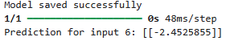12
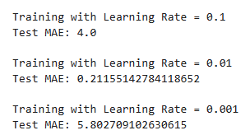 11
#12
import numpy as np
from tensorflow.keras.models import Sequential, load_model
from tensorflow.keras.layers import Dense
import tensorflow as tf
X = np.array([[1], [2], [3], [4], [5]])
y= np.array([2,4,6,8,10])
model =Sequential()
model.add(Dense (8, activation= 'relu', input_shape=(1,)))
model.add(Dense(1))
model.compile(optimizer='adam', loss=tf.keras.losses.MeanSquaredError())
model.fit(X, y, epochs=100, verbose=0)
model.save("linear_model.h5")
print("Model saved successfully")
loaded_model= load_model("linear_model.h5")
prediction =loaded_model.predict(np.array([[6]]))
print("Prediction for input 6:", prediction)

#13. GAN to Generate Images
from tensorflow.keras.models import Sequential
from tensorflow.keras.layers import Dense
import numpy as np
generator = Sequential([
Dense(16, activation='relu', input_shape=(10,)),
Dense(784, activation='sigmoid')])
noise = np.random.normal(0, 1, (1, 10)) # Added missing '=' sign
generated_image = generator.predict(noise)
print("Generated image shape:", generated_image.shape)
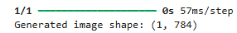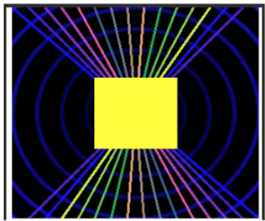

14
!pip install opencv-python
import cv2
import numpy as np
from IPython.display import display, Image
height, width = 300, 300
img = np.zeros((height, width, 3), dtype=np.uint8)
for i in range(0, height, 30):
color = (i % 256, (1*2) % 256, (1*3) % 256)
cv2.circle(img, (width//2, height//2), i, color, 3)
for i in range(0, width, 20):
cv2.line(img, (i, 0), (width-i, height), (255-i% 256, i% 256, (i*3) % 256), 2)
cv2.rectangle(img, (100, 100), (200, 200), (0,255, 255), -1)
cv2.imwrite("unique_image.jpg", img)
display(Image(filename="unique_image.jpg"))

15)
import numpy as np
from tensorflow.keras.models import Sequential
from tensorflow.keras.layers import SimpleRNN, Dense
# Example: sequence [0,1,2,3,4,5,...), predict next number
x_train = np.array([[0, 1, 2], [1, 2, 3], [2, 3, 4], [3, 4, 5]], dtype=float)
y_train = np.array ([3, 4, 5, 6], dtype=float)
x_train = x_train.reshape((x_train.shape[0], x_train.shape[1], 1))
model = Sequential()
model.add(SimpleRNN (10, activation ='relu', input_shape=(3, 1)))
model.add(Dense (1)) # Output Layer
model.compile(optimizer='adam', loss='mse')
model.fit(x_train, y_train, epochs=200, verbose=0)
test_input = np.array([4, 5, 6]).reshape((1, 3, 1))
predicted = model.predict(test_input, verbose=0)
print("Next number prediction:", predicted[0][0])

15

